RootedIN

Abundance
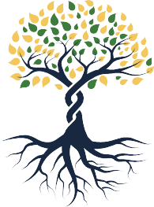
Cultura



When I think of being rooted in abundance, the first image that comes to mind is my grandmother. In my small hometown in Zacatecas, my grandmother’s house was where everybody went for a meal or a listening ear. Her table served not just food but wisdom.
My people were poor, but there was always enough. We learned how to give what we had for the good of everyone. I was taught that giving meant more than just giving money. My grandmother taught me to give myself fully to God.
My roots are my cultura. In Latino culture, it’s never about the individuals or the immediate family but about being rooted in each other. My grandmother’s life was hard, but she was so
Talk about a time when you were planted in a new place or a new position.
How did you find a root structure to ground you?
Questions for Reflection:
connected to God, the earth, and all that is holy. Being in Austin, where I teach at the Seminary of the Southwest, has called me to grow closer to her and her lessons. I felt disconnected from anything familiar for the first few months here. I didn’t yet see
that God was planting me in a new place and that something new was growing within me. Now I know that my colleagues here are also my people. I feel my roots taking hold of the land here, and I will trust God. If my grandma can do it, so can I.
Trees are an image of stewardship of abundance and not just survival. Communities of color and poor communities in the episcopal church are sometimes treated as “poor people” who can’t give. We must switch that mentality and consider these communities’ newly planted trees. They will not grow overnight, but if we care for and nurture them, these communities will thrive and plant deep roots. The roots will be interconnected in a community of love of God and neighbor where there is always enough for everyone. |

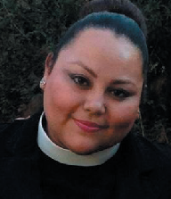
The Reverend Nancy Aidé Frausto is Director of Latinx Studies, Seminary of the Southwest.

